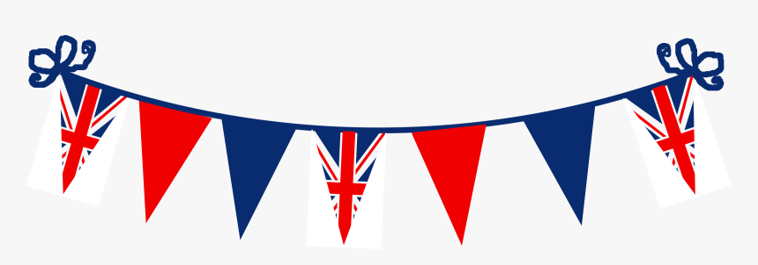

Bring your picnic and celebrate the Queen’s Jubilee on the Green in Brasted on Sunday 5 June, 1pm – 4pm.

The parish council will be setting up tables, chairs and decorations for Brasted residents to come and celebrate the Queen’s Jubilee together.

The Teashop is planning to be open for refreshments, the Stanhope Arms will be selling beer and Pimm’s on the Green and there will also be a children’s fancy dress competition.

