Brasted Parish Council
Christmas Tree Lights Switch On

Please join us on The Green on
Friday 3rd December from 6pm

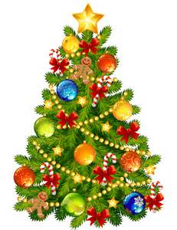
If you are a Brasted resident aged 5-11 and would like to switch on the lights, email clerk@brastedpc.org.uk or phone 01732 455374, with your name and e mail address before Monday 29 November and we will draw a name. Good luck!

The Teashop opposite the Green has very kindly agreed to open for the light up to provide refreshments on the night.

